**Exercise 3: Stored Procedures**

**Scenario 1:** The bank needs to process monthly interest for all savings accounts.

**Question:** Write a stored procedure **ProcessMonthlyInterest** that calculates and updates the balance of all savings accounts by applying an interest rate of 1% to the current balance.

**Program:**

CREATE OR REPLACE PROCEDURE ProcessMonthlyInterest IS

BEGIN

FOR acc IN (

SELECT AccountID, Balance

FROM Accounts

WHERE AccountType = 'Savings'

) LOOP

UPDATE Accounts

SET Balance = Balance + (acc.Balance * 0.01)

WHERE AccountID = acc.AccountID;

DBMS_OUTPUT.PUT_LINE(

'1% interest added to Account ID: ' || acc.AccountID ||

', New Balance: ' || TO_CHAR(acc.Balance * 1.01, '9999.99')

);

END LOOP;

COMMIT;

END;

/

**Executing the Procedure :**

BEGIN

ProcessMonthlyInterest;

END;

/

**Output:**

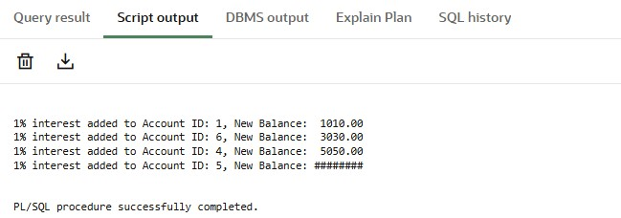

**Scenario 2:** The bank wants to implement a bonus scheme for employees based on their performance.

**Question:** Write a stored procedure **UpdateEmployeeBonus** that updates the salary of employees in a given department by adding a bonus percentage passed as a parameter.

**Program** :

CREATE OR REPLACE PROCEDURE UpdateEmployeeBonus(

p_dept IN VARCHAR2,

p_bonus_percent IN NUMBER

) IS

BEGIN

FOR emp IN (

SELECT EmployeeID, Name, Salary

FROM Employees

WHERE Department = p_dept

) LOOP

UPDATE Employees

SET Salary = Salary + (emp.Salary * (p_bonus_percent / 100))

WHERE EmployeeID = emp.EmployeeID;

DBMS_OUTPUT.PUT_LINE(

'Bonus of ' || p_bonus_percent || '% applied to ' || emp.Name ||

' (ID: ' || emp.EmployeeID || '), New Salary: ' ||

TO_CHAR(emp.Salary * (1 + p_bonus_percent / 100), '999999.99')

);

END LOOP;

COMMIT;

END;

/

**Executing the Procedure:**

BEGIN

UpdateEmployeeBonus('IT', 10);

END;

/

**Output:**

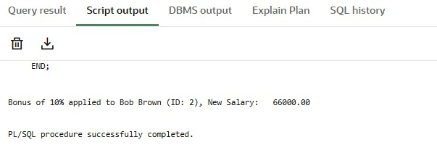

**Scenario 3:** Customers should be able to transfer funds between their accounts.

**Question:** Write a stored procedure **TransferFunds** that transfers a specified amount from one account to another, checking that the source account has sufficient balance before making the transfer.

**Program:**

CREATE OR REPLACE PROCEDURE TransferFunds(

p_from_account_id IN NUMBER,

p_to_account_id IN NUMBER,

p_amount IN NUMBER

) IS

v_from_balance NUMBER;

BEGIN

SELECT Balance INTO v_from_balance

FROM Accounts

WHERE AccountID = p_from_account_id;

IF v_from_balance >= p_amount THEN

UPDATE Accounts

SET Balance = Balance - p_amount

WHERE AccountID = p_from_account_id;

UPDATE Accounts

SET Balance = Balance + p_amount

WHERE AccountID = p_to_account_id;

DBMS_OUTPUT.PUT_LINE('Transfer of ₹' || p_amount || ' successful from Account ' ||

p_from_account_id || ' to Account ' || p_to_account_id);

ELSE

DBMS_OUTPUT.PUT_LINE('Insufficient funds in Account ' || p_from_account_id);

END IF;

COMMIT;

EXCEPTION

WHEN NO_DATA_FOUND THEN

DBMS_OUTPUT.PUT_LINE('One of the accounts does not exist.');

WHEN OTHERS THEN

DBMS_OUTPUT.PUT_LINE('An unexpected error occurred: ' || SQLERRM);

END;

/

**Executing the Procedure**:

BEGIN

TransferFunds(2, 1, 200);

END;

/

**Output:**

